**The Hurdle Race**

**locked**

**by**[**ma5termind**](https://www.hackerrank.com/ma5termind)

* [**Problem**](https://www.hackerrank.com/contests/hourrank-17/challenges/the-hurdle-race)
* [**Submissions**](https://www.hackerrank.com/contests/hourrank-17/challenges/the-hurdle-race/submissions)
* [**Leaderboard**](https://www.hackerrank.com/contests/hourrank-17/challenges/the-hurdle-race/leaderboard)
* [**Discussions**](https://www.hackerrank.com/contests/hourrank-17/challenges/the-hurdle-race/forum)
* [**Editorial**](https://www.hackerrank.com/contests/hourrank-17/challenges/the-hurdle-race/editorial)

Dan is playing a video game in which his character competes in a hurdle race by jumping over  hurdles with heights . He can initially jump a maximum height of  units, but he has an unlimited supply of magic beverages that help him jump higher! Each time Dan drinks a magic beverage, the maximum height he can jump during the race increases by  unit.

Given , , and the heights of all the hurdles, find and print the *minimum* number of magic beverages Dan must drink to complete the race.

**Input Format**

The first line contains two space-separated integers describing the respective values of  (the number of hurdles) and  (the maximum height he can jump without consuming any beverages).   
The second line contains  space-separated integers describing the respective values of .

**Constraints**

**Output Format**

Print an integer denoting the *minimum* number of magic beverages Dan must drink to complete the hurdle race.

**Sample Input 0**

5 4

1 6 3 5 2

**Sample Output 0**

2

**Explanation 0**

Dan's character can jump a maximum of  units, but the tallest hurdle has a height of :

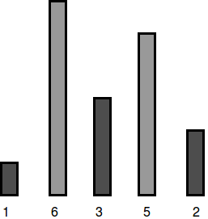

To be able to jump all the hurdles, Dan must drink  magic beverages.

**Sample Input 1**

5 7

2 5 4 5 2

**Sample Output 1**

0

**Explanation 1**

Dan's character can jump a maximum of  units, which is enough to cross all the hurdles:

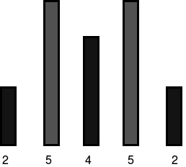

Because he can already jump all the hurdles, Dan needs to drink  magic beverages.

<https://www.hackerrank.com/contests/hourrank-17/challenges/the-hurdle-race>

using System;

using System.Collections.Generic;

using System.Linq;

using System.Text;

namespace ConsoleApplication1

{

class Program

{

static void Main(string[] args)

{

string[] tokens_n = Console.ReadLine().Split(' ');

int n = Convert.ToInt32(tokens_n[0]);

int k = Convert.ToInt32(tokens_n[1]);

string[] height_temp = Console.ReadLine().Split(' ');

int[] height = Array.ConvertAll(height_temp, e => int.Parse(e));

Console.WriteLine(height.Max() - k >= 0 ? height.Max() - k : 0);

Console.ReadLine();

}

}

}